Name___________________________________ Keena Ford and the Second-Grade Mix-Up
Making Predictions

1. Based on the preview on the back of the book, what do you predict will happen? Why?
_________________________________________________________________________________________________________________________________________________________

2. What do you predict Keena will do to “get out of this mess”?
_________________________________________________________________________________________________________________________________________________________
Name___________________________________ Keena Ford and the Second-Grade Mix-Up

Key Details

Who? | What?
When? | Where?
Why? | How?
Name___________________________________ Keena Ford and the Second-Grade Mix-Up
Story Map

Characters | Setting
Problem | Solution

Name___________________________________ Keena Ford and the Second-Grade Mix-Up
Character Development

Feelings  Keena  Ford | Actions  N
Sayings | Thoughts

Name___________________________________ Keena Ford and the Second-Grade Mix-Up
Character Traits
Character | Trait | Evidence
Keena
Ford
Keena’s
Mom
Keena’s
Dad
Brian
Ms. Campbell
Eric

Name___________________________________ Keena Ford and the Second-Grade Mix-Up
Character Actions & Motivation

Keena Ford

Character Actions | Motivation

Name___________________________________ Keena Ford and the Second-Grade Mix-Up
Vocabulary
Word:_______________ Definition:
____________________
____________________
____________________
Sentence:
____________________
____________________
____________________

Word:_______________ Definition:
____________________
____________________
____________________
Sentence:
____________________
____________________
____________________

Name___________________________________ Keena Ford and the Second-Grade Mix-Up
Friendly Letter
___________
____________
________________________________________________________________________________________________________________________________________________________________________________________________________________
____________
____________

Name___________________________________ Keena Ford and the Second-Grade Mix-Up

Honesty is the Best Policy!
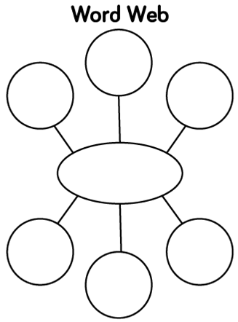

Honesty

Name___________________________________ Keena Ford and the Second-Grade Mix-Up

Honesty is the Best Policy!

______________________________________________________________________________________________________________________________________________________________________________________________________________________________________________________________________________________________________________________________________________________________________________________________________________________________________________________________________________________________________________________________________________________________________________________________________________________________________________________________________________________________________________________________________________________________________________________________________________________________________________________________________________________________________________________________________________________________________________________________________________________________________________________________________________________________________________________
Name___________________________________ Keena Ford and the Second-Grade Mix-Up

Honesty is the Best Policy!

What it looks like:

Keena Ford

You

Name___________________________________ Keena Ford and the Second-Grade Mix-Up
Character Study
RL.2.3 Describe how characters in a story respond to major events and challenges

Event #1: __________________________________________________________________________

Event #1 Character Response: __________________________________________________________________________

Event #2: __________________________________________________________________________

Event #2 Character Response: __________________________________________________________________________

Page 1

Event #3: __________________________________________________________________________

Event #3 Character Response: __________________________________________________________________________

Event #4: __________________________________________________________________________

Event #4 Character Response: __________________________________________________________________________

Page 2
_____________’s Journal
Date:_________________
__________________________________________________________________________________________________________________________________________________________________________________________________________________________________________________________________________________________________________________________________________________________________________________________________________________________

Name___________________________________ Keena Ford and the Second-Grade Mix-Up
My Story Notes
My questions
I laughed when

My favorite part
I was surprised about

Name___________________________________ Keena Ford and the Second-Grade Mix-Up
Making a Connection
What is a compromise?
__________________________________________________________________________________
What compromise did Keena have to make?
__________________________________________________________________________________
Think about a time you had to make a compromise. Write about it.
________________________________________________________________________________________________________________________________________________________________________________________________________________________________________________________________________________________________________________________________________

